**Moulton Pre-School – Food Hygiene Policy**

|  |  |
| --- | --- |
| **Version:** | 2.1 |
| **Author:** | Alex Bowers |
| **Approved and signed by:** | Moulton Pre-School Committee |
| **Date:** |  |
| **Review Date:** |  |

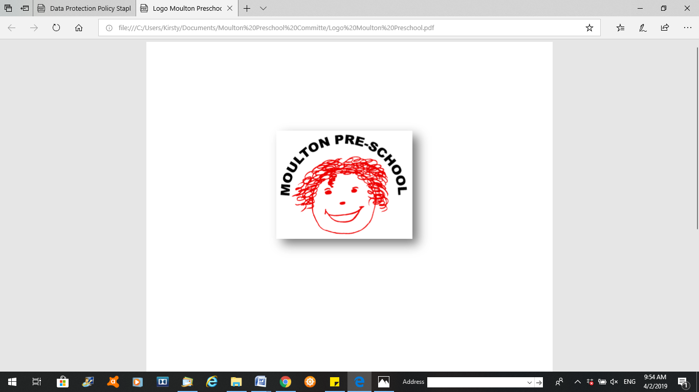

# Food Hygiene

**03 Food safety and nutrition policy**

# Aim

Our setting is a suitable, clean, and safe place for children to be cared for, where they can grow and learn. We meet all statutory requirements for food safety and fulfil the criteria for meeting the relevant Early Years Foundation Stage Safeguarding and Welfare requirements

###### **Objectives**

* We recognise that we have a corporate responsibility and duty of care for those who work in and receive a service from our provision, but individual employees and service users also have responsibility for ensuring their own safety as well as that of others. Risk assessment is the key means through which this is achieved.
* We provide nutritionally sound meals and snacks which promote health and reduce the risk of obesity and heart disease that may begin in childhood.
* We follow the main advice on dietary guidelines and the legal requirements for identifying food allergens when planning menus based on the four food groups:
* meat, fish, and protein alternatives
* milk and dairy products
* cereals and grains
* fresh fruit and vegetables.
* Following dietary guidelines to promote health also means taking account of guidelines to reduce risk of disease caused by unhealthy eating.
* Parents share information about their children’s particular dietary needs with staff when they enrol their children and on an on-going basis with their key person. This information is shared with all staff who are involved in the care of the child.
* Foods provided by the setting for children have any allergenic ingredients identified on the menus.
* Care is taken to ensure that children with food allergies do not have contact with food products that they are allergic to.
* Risk assessments are conducted for each individual child who has a food allergy or specific dietary requirement.
* When children take part in cooking activities, they:
* are supervised at all times;
* understand the importance of hand washing and simple hygiene rules
* are kept away from hot surfaces and hot water; and
* do not have unsupervised access to electrical equipment such as blenders etc.

## Reporting of food poisoning

Food poisoning can occur for a number of reasons; not all cases of sickness or diarrhoea are as a result of food poisoning and not all cases of sickness or diarrhoea are reportable.

* Where children and/or adults have been diagnosed by a GP or hospital doctor to be suffering from food poisoning and where it seems possible that the source of the outbreak is within the setting, the Manager will contact the Environmental Health Department and the Health Protection Agency, to report the outbreak and will comply with any investigation.
* We notify Ofsted as soon as reasonably practical of any confirmed cases of food poisoning affecting two or more children looked after on the premises, and always within 14 days of the incident.

**Legal references**

Regulation (EC) 852/2004 of the European Parliament and of the Council on the hygiene of foodstuffs.

Food Information Regulations 2014

The Childcare Act 2006

**Further guidance**

[*Safer Food Better Business* for Caterers](http://www.food.gov.uk/business-guidance/safer-food-better-business-for-caterers) (Food Standards Agenc ***Moulton Pre-school is committed to safeguarding and promoting the welfare of children, young people and adults at all times and expects everybody working within this setting to share this commitment.***